Anjitha Biju Nair, E5685577

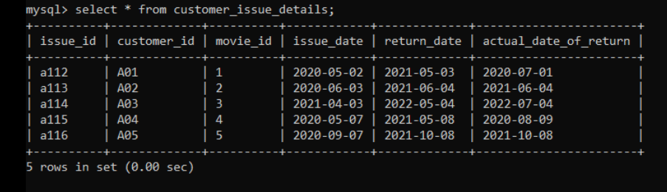

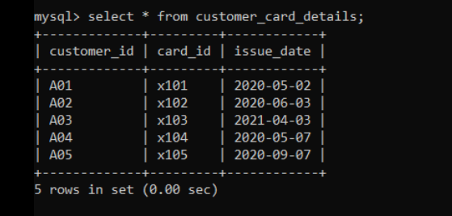

Q1)

Q3)

Q4)

Q5)



Q6)



OTHER CASE (taken movies from lib with library card)

Q7)

Q8)

Q9)

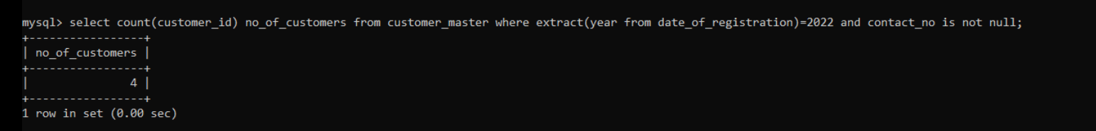

Q10)



COUNT=1, movie_category = sci-fi

